Part Number: PT908-47161

Kit Contents
Item # | Quantity Reqd. | Description
1 | 1 | Cargo Tray
2 | 1 | Seat Back Cover – driver side
3 | 1 | Seat Back Cover – pass. side
4 | 1 | Hinge Cover – driver side
5 | 1 | Hinge Cover – pass. side
Hardware Bag Contents
Item # | Quantity Reqd. | Description
1
2
3
Additional Items Required For Installation
Item # | Quantity Reqd. | Description
1
2
3
Conflicts
Vehicles with tire inflation kit only (no spare tire)
Recommended Tools
Personal & Vehicle Protection | Notes
Cover or blanket
Special Tools | Notes
None
Installation Tools | Notes
None
Special Chemicals | Notes
None
General Applicability
Vehicles with mini-spare
Recommended Sequence of Application
Item # | Accessory
1 | Cargo Tray
2 | Cargo Net
3
*Mandatory
Vehicle Service Parts (may be required for reassembly)
Item # | Quantity Reqd. | Description
1
2
3
Legend
STOP: Damage to the vehicle may occur. Do not proceed until process has been complied with.
OPERATOR SAFETY: Use caution to avoid risk of injury.
CAUTION: A process that must be carefully observed in order to reduce the risk of damage to the accessory/vehicle and to ensure a quality installation.
TOOLS & EQUIPMENT: Used in Figures calls out the specific tools and equipment recommended for this process.
REVISION MARK: This mark highlights a change in installation with respect to previous issue.
SAFETY TORQUE: This mark indicates that torque is related to safety.

Care must be taken when installing this accessory to ensure damage does not occur to the vehicle. The installation of this accessory should follow approved guidelines to ensure a quality installation.

These guidelines can be found in the "Accessory Installation Practices" document.

This document covers such items as:-
- Vehicle Protection (use of covers and blankets, cleaning chemicals, etc.).
- Safety (eye protection, rechecking torque procedure, etc.).
- Vehicle Disassembly/Reassembly (panel removal, part storage, etc.).
- Electrical Component Disassembly/Reassembly (battery disconnection, connector removal, etc.).

Please see your Toyota dealer for a copy of this document.

Prepare for the Install.
  - Open the package and check the part for damage and kit contents, including the adapter pads attached to the seat back and hinge covers.
  - Open the rear hatch door and remove any stored items and debris from the cargo area.
  - Place vehicle protection over the rear bumper.
  - Open both the rear driver and rear passenger doors and lower the seatbacks down.

Install the Seatback Covers.
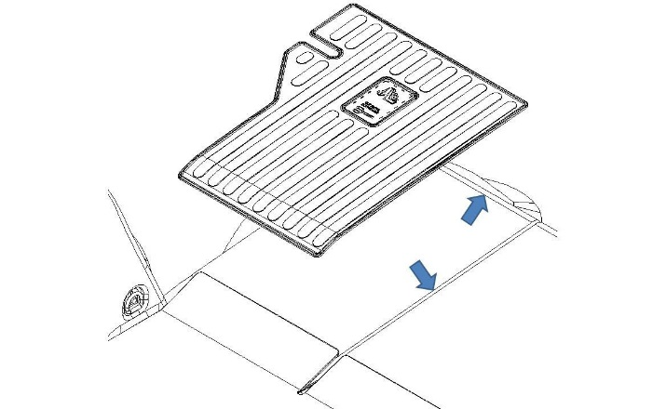
  - Before removing the white covers from the adapter pads, align the driver side seat back cover with the seam lines of the seat back (Fig. 2-1).
Fig. 2-1

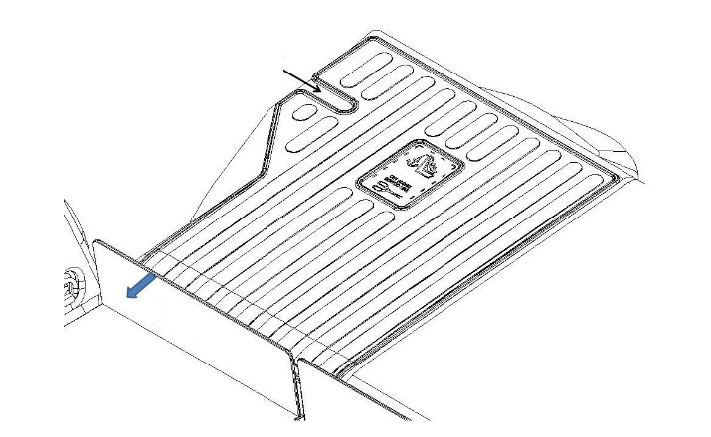
  - Check to ensure the seat latch is centered in the opening. Adjust if needed (Fig. 2-2).
Fig. 2-2
Step 2(b)
Step 2(c)
Hinge
  - Push the hinge rearward to ensure the seat back cover is resting on the seat. Rub firmly along the bottom edge of the cover to secure the hook fastener to the seat (Fig. 2-2).

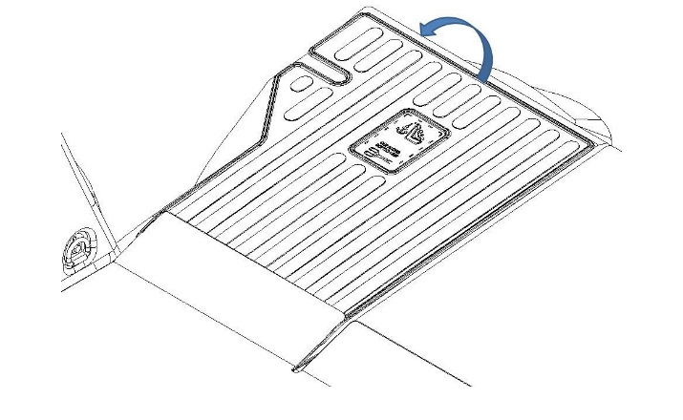
  - Grasp the front edge of the seat back cover and slowly bend the cover up and rearward to reveal the adapter pads. Remove the white cover from the 5 pads and lower the cover down onto the seat back. Firmly rub the cover over the adapter pad locations to ensure attachment (Fig. 2-3).
Fig. 2-3
  - Repeat Steps 2(a) through 2(d) on the passenger side.
NOTE: The passenger side has 8 adapter pads.

Install the Hinge Covers.
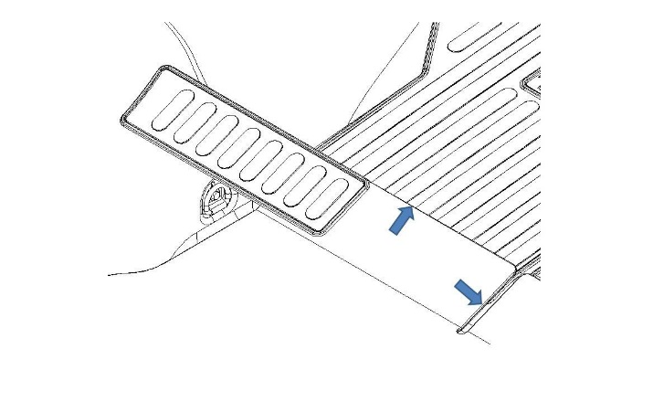
  - Test fit the driver side hinge cover to the hinge assembly by aligning the front and inboard edges (Fig. 3-1).
Fig. 3-1

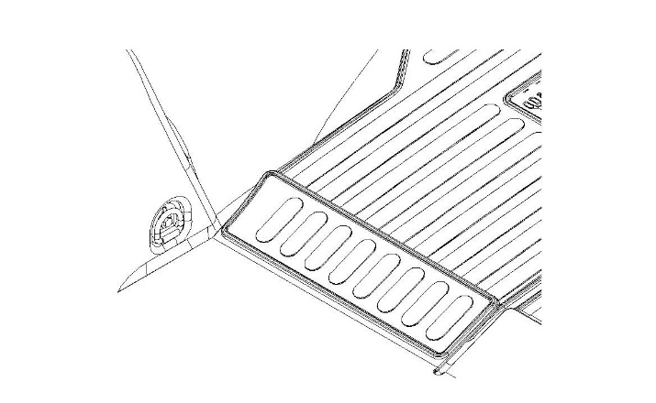
  - Remove the white cover from the adapter pads; carefully align and lightly install them. After confirming correct alignment, firmly rub the cover over the adapter pad locations to ensure attachment (Fig. 3-2).
Fig. 3-2
  - Repeat Steps 3(a) and 3(b) to install the passenger side hinge cover.

Install the Cargo Tray.
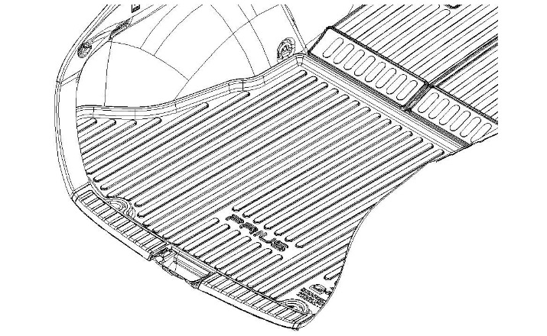
  - Place the Cargo Tray in the cargo area with the logo towards the rear of the vehicle and facing up (Fig 4-1).
Fig. 4-1
  - After installing the tray, ensure all of the edges are pushed down against the floor.

Complete the Installation.
  - Remove the vehicle protection.
  - Close the doors.

Accessory Function Checks
Correct part number installed

Vehicle Function Checks

Verify part number on package

Vehicle Appearance Check
After accessory installation and removal of protective cover(s), perform a visual inspection.

Ensure no damage (including scuffs and scratches) was caused during the installation process.
(For PPO installations, refer to TMS Accessory Quality Shipping Standard.)

